Haorui Zhang

1/2612019

HW 3

2. X -> $S0, Y -> $S1

addi $S2, $S1, 5 #s2 = y+5

slt $t1, $S0, $S2 #If x< s2, t1 = 1, else t1 =0

beq $t1, $ZERO, else #if x>y+5, go to else

sub $S1, $S0, $S1 #y=x-y

j EXIT #go to exit

else:

add $S0, $S0, $S1 #x=x+y

EXIT #Quit

1. X->$S0, Y->$S1

Loop:

addi $S2, $S1,5 #s2 = y+5

slt $t1, $S0, $S2 #if x< y+5, t1 = 1, else t1 =0

beq $t1, $ZERO, else #if x>y+5, go to else block

EXIT #if x<y+5, quit

else:

addi $S0, $S0, -1 #x--

addi $S0, $S0, -1 #x--

addi $S1, $S1, 1 #y++

J Loop #back to loop

1. X -> $S0, Y -> $S1

addi $S0, $ZERO, 1 #set x =1

Loop:

sgt $t1, $S0, $S1 #if x>y, t1 = 1, else, t1=0

beq $t1, $zero, else #If x<y, go to else block

Exit #If x>Y, quit

else:

addi $S0, $S0, 5 #x=x+5

addi $S1, $S1, 1 #y++

addi $S0, $S0, 1 #x++

j Loop

1. 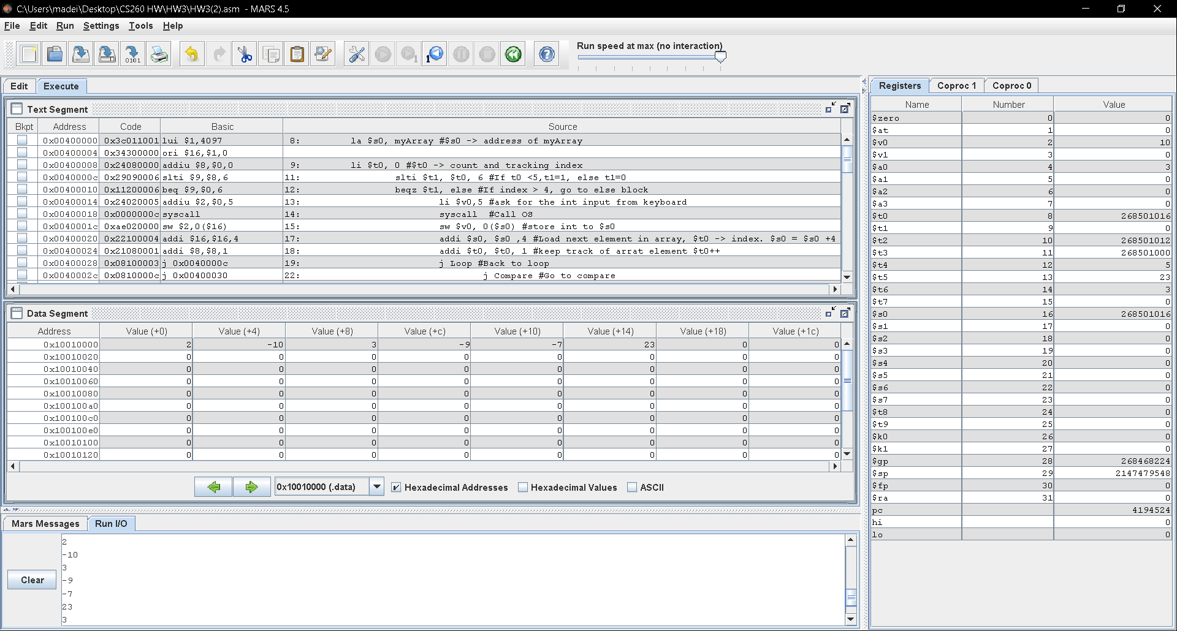
2. Since addi instruction works with 16 bits number, the smallest number for this instruction is: -32768.